Project Design Phase-II

Data Flow Diagram & User Stories

|  |  |
| --- | --- |
| Date | 15 October 2022 |
| Team ID | PNT2022TMID51155 |
| Project Name | Smart Fashion Recommender Application |
| Maximum Marks | 4 Marks |

Data Flow Diagrams:

A Data Flow Diagram (DFD) is a traditional visual representation of the information flows within a system. A neat and clear DFD can depict the right amount of the system requirements graphically. It shows how data enters and leaves the system, what changes the information, and where data is stored.

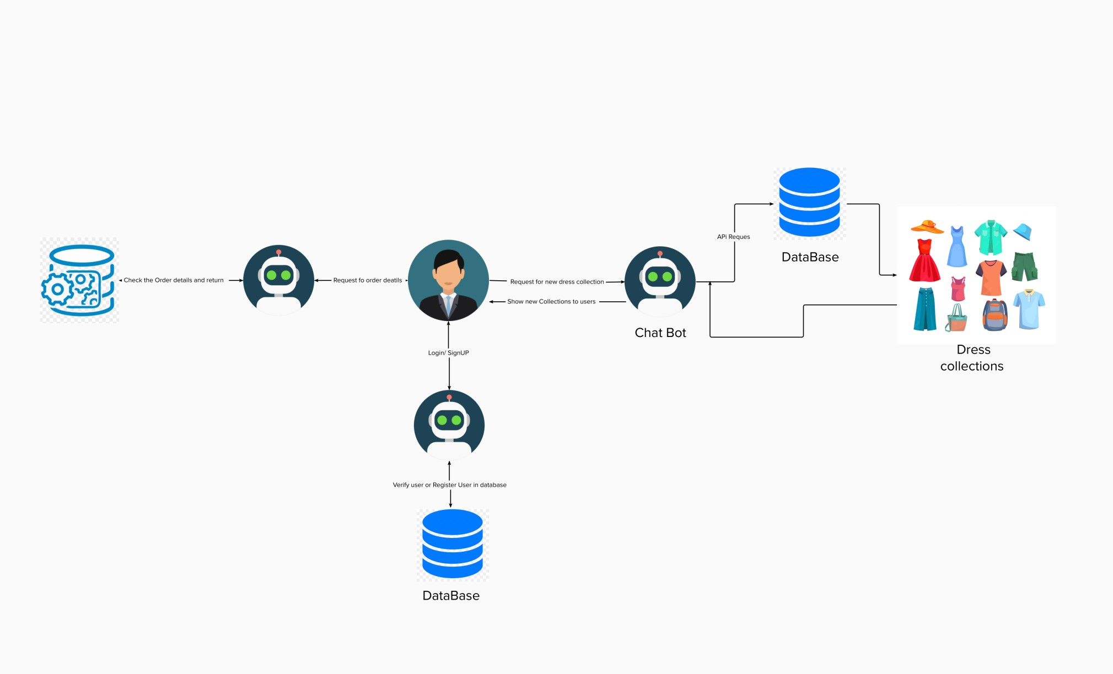

|  |  |  |  |  |  |  |
| --- | --- | --- | --- | --- | --- | --- |
| User Type | Functional  Requirement  (Epic) | User Story  Number | User Story / Task | Acceptance criteria | Priority | Release |
| User | Registration | USN-1 | As a user, I can register for the application by entering my email, password, and confirming my password. | I can access my account / dashboard | High | Sprint-1 |
|  |  | USN-2 | As a user, I will receive confirmation email once I have registered for the application | I can receive confirmation email & click confirm | High | Sprint-1 |
|  | Login | USN-3 | As a user, I can login for the application by entering email & password | I can login for the application by entering email & password | High | Sprint-1 |
|  | Dashboard | USN-4 | Browse the products that are offered on the website. The consumer can speak with chatbot directly about the products rather of having to navigate through numerous menus to make an online purchase | I can purchase product using chatbot instead of searching |  | Sprint-1 |
|  | Chatbot | USN-5 | Using chatbot we can manage user's choices and orders |  | High | Sprint-2 |
|  |  | USN-6 | The chatbot can give recommendations to the users based on their interests. | I can view related products of my interests | High | Sprint-3 |
|  |  | USN-7 | It can promote the best deals and offers on that day. | I can view offers and prizes | High | Sprint-2 |
|  |  | USN-8 | It will store the customer's details and orders in the database. |  | High | Sprint-3 |
|  |  | USN-9 | The chatbot will send a notification to customers if the order is confirmed. | I get confirmation message | High | Sprint-2 |
|  | The flow of orders and checkout | USN-10 | Order statuses are displayed on the website:  confirmed, processing, shipped, returned. | I can view my status in each step |  |  |
| Admin | Maintaining | USN-1 | They maintain a record of everything that users are purchasing. |  | High | Sprint-2 |
|  |  | Usn-2 | The administrator's job is to search the stock database. |  |  | Sprint-2 |

**User Stories**